**Data published in:** Lankinen, Å., Madjidian, J.A., Andersson, S. 2017. Geographic variation in floral traits is associated with environmental and genetic differences among populations of the mixed mating species *Collinsia heterophylla* (Plantaginaceae). Botany 95: 121-138. doi: 10.1139/cjb-2016-0014

**Plant material and study populations**

In 2008, between 29 April and 14 May, we sampled 27 populations in California (Table A1), of which 22 populations could be used for gathering floral trait data in the field (marked F in Table A1). Seeds for the greenhouse study were obtained from 20 populations (marked G),

including 15 of those used in the field investigation (marked F, G). Our aim was to sample populations that covered the majority of the climatic and ecological variability encountered by the species. The sample range of our populations was 750 km and represents about two thirds of the north–south range of the species. Populations can be found both north and south of the sampling area, i.e., our outermost populations are relatively distant from the range limit. For practical reasons we sampled populations in four regions of the total study area, where region was defined according to our sampling scheme. In the south, we sampled populations both south of Los Angeles in the Santa Ana Mountains (Riverside County, region 1) and north of Los Angeles in the Transverse Ranges and the Coast Ranges (Los Angeles, Ventura, and Santa Barbara counties, region 2). Further north, we sampled populations in the Sierra Nevada Mountains (Mariposa and Madera counties, region 3) and the Coast Ranges around the Bay area (Santa Clara, Alameda, and Napa counties, region 4). Region and population represent geographical effects varying at large and small scale, respectively. These large- and small-scale effects may or may not represent specific environmental variables such as climate and site characteristics (see below).

**Collection of field data**

To quantify geographic variation of floral phenotype, we measured eight traits in the field. Two traits, corolla colour and the presence/absence of dark pigment on the upper lip, were scored in all 22 populations that were flowering during our field work. To increase sample size for these two traits, we also included data collected in 2003 (Å. Lankinen, unpublished data) from two early flowering populations (203 and 204, Table A1). Timing of anther–stigma contact, timing of stigma receptivity (time to first sign of receptivity, termed partial receptivity, and full receptivity, respectively), and flower size (keel length, banner height, and corolla tube length) were assessed in 13 populations (2–4 populations per region, Table A1). Plants had reached an advanced stage at the time of data collection (most plants had reached anthesis and some individuals had started to set seed). We aimed to include as many populations as possible, which limited the number of measurements made within populations.

**Measurements of floral traits**

We assessed timing of anther–stigma contact by recording at which floral developmental stage the anthers and stigma first came into physical contact. Floral stages were defined as 0–4, reflecting the number of dehisced anthers (following Armbruster et al. 2002). (= method for estimating stage of anther-stigma contact in excel fil, see details for greenhouse estimates below) We examined 10 flowers per floral developmental stage (i.e., a total *N* of 50), each from a different individual, haphazardly chosen from the population, and determined whether anthers did or did not contact the stigma. When 10 flowers of a particular stage had been found, we disregarded flowers of that stage. We used logistic regression (Statistica 7.1,

2005) to estimate the stage at which 50% of all flowers had their anthers in direct contact with the stigma (see Armbruster et al. 2002). This measure, denoted “stage of anther–stigma contact” together with the corresponding logistic regression coefficient, quantifies when flowers in the population reached anther–stigma contact relative to flower opening.

To estimate stages of stigma receptivity we assessed stigmatic peroxidase activity at stage 0–4 by placing intact, pollen-free stigmas (checked by visual inspection under a magnifying glass) on a microscopic slide in a drop of 3% hydrogen peroxide and covering with a cover

slip (Kearns and Inouye 1993). Vigorous bubbling on the stigmatic surface within a few minutes has been observed to indicate full stigma receptivity (Lankinen et al. 2007). (= method for estimating stage of stigma receptivity in excel fil, see details for greenhouse estimates below) We examined 10 flowers per developmental stage (i.e., *N* = 50), each from a separate individual, haphazardly chosen and usually excluding those scored for other traits. We determined (using logistic regression) the stage when 50% of all flowers showed full receptivity, denoted “stage of stigma receptivity,” and used the logistic regression coefficient to estimate how quickly flowers in the population reached stigma receptivity. Because some pollen donors can germinate on partly-receptive stigmas (Lankinen and Kiboi 2007), causing negative effects on maternal seed set in line with a sexual conflict over timing of stigma receptivity (Madjidian et al. 2012*a*), we were also interested in whether populations differ in how stigma receptivity progresses: rapid development from unreceptive to fully receptive stigmas (i.e., a short period of partial receptivity) could be beneficial if it prevents early pollen germination. Thus, we determined the stage when 50% of all flowers showed partial receptivity (as indicated by at least two small bubbles) and the corresponding logistic regression coefficient. In addition we used the difference between stage of full and partial receptivity (from the logistic regression estimates) as a measure of the rate with which flowers went from partial to full receptivity.

We assessed flower size by measuring keel length, height of the upper lip (banner height), and corolla tube length (for details, see figure 1 in Armbruster et al. 2002). (= method for estimating keel length in excel file, see details for greenhouse estimates below) All three measurements were conducted on 10 flowers per population (all from different, haphazardly chosen individuals, usually not including those scored for other traits). Additionally, we determined corolla colour by scoring the base colour of corollas as light purple (nearly white), intermediate purple, or dark purple. (= method for estimating flower colour in excel file, see details for greenhouse estimates below) Even though some continuous colour variation exists, our populations were sufficiently uniform to fall into these three categories. Populations 19, 181, and 182 had additional yellowish markings (see Garber 1958) but were categorized according to their base colour (light purple). In populations polymorphic for presence/absence of pigment on the upper lip, we estimated the proportion of plants with and without pigment (referred to as the darkand white-lipped morph, respectively) by assessing all plants along one or a few transects laid out in each population (200–300 plants per population).

**Selection of floral traits for further analysis**

To select the most informative and least redundant traits for further analyses we performed a principal component analysis (PCA) on population-level estimates of the 12 floral traits generated in the field study (13 populations). Based on the results of this analysis (Table A2),

we selected stage of anther–stigma contact, stage of stigma receptivity, keel length and the second principal component (PC 2) in further analyses. To reduce the number of dependent variables for the analyses of the 13 populations, PC 2 was used as a proxy for the two positively correlated traits corolla colour and colour morph ratio (Spearman *r* = 0.770, *N* = 22, *P* < 0.0001), hereinafter referred to “combined flower colour.” Corolla colour and

colour morph ratio of all 24 populations were also used in complementary separate analyses.

**Collection of greenhouse data**

In spring 2011, we performed a large cultivation experiment to determine genetically based variation within and between populations (Table A1). Plants from the field-collected seeds (collected per maternal family) were grown in pots with standard potting soil (565 cm3), placed in random positions across eight adjacent benches in a semi-automated, pollinator-free greenhouse at the Dept. of Biology, Lund University (Sweden). We used artificial light (14 h) to complement natural daylight in early spring, and an automated shade cloth system to prevent direct sunlight from reaching the plants. Greenhouse temperature varied between 20 and 30 °C, depending on outside weather condition. We watered plants as soon as the soil started to dry out to avoid any water stress. A total of 20 populations were used in the greenhouse study, including the five early-flowering populations not scored for floral traits in the field study (Table A1). To increase sample size in our field-greenhouse comparison, we compared greenhouse data from population 142 with field data collected from a closely adjacent population (pop. 14, Table A1). We assume that because of their close proximity (<1 km) and overlapping flowering time, these populations have the potential to exchange genes and share similar selection pressures. On average, each population was represented by 13.8 ± 5.6 (SD) maternal families (range = 5–27 families), with 1–5 offspring per family and a total *N* of 987.

Floral traits measured in the greenhouse were the same as in the field except that we also scored the greenhouse-grown plants for floral phenology (time to first flower from date first individual of all populations started flowering, *N*pop = 20, see Table A1 = day of flowering start in excel file). Corolla colour (= flower colour in excel file) and presence/absence of dark pigment on the upper lip (= band on upper lip in excel file) were assessed on each greenhouse-grown plant (*N*pop = 17). Estimates of stage of anther–stigma contact (= stage of anther-stigma contact in excel file) and stigma receptivity (= stage of stigma receptivity in excel file) were based on data from two replicate flowers per developmental stage (1–4), i.e., a total of 8 flowers per plant. To prevent self-pollination and test for stigmatic receptivity we emasculated newly opened flowers (i.e., at stage 0 = day 0) and used days 1–4 as a proxy for stage (Lankinen et al. 2007). For stage of anther–stigma contact and keel length (= keel length in excel file), we obtained data from 1–2 plants per maternal family for on average 13.2 families per population (range = 5–15 families/population, *N*pop = 13, see Table A1). For stage of stigma receptivity we obtained data from one plant per maternal family for on average 9.6 families per population (range = 5–10 families/population, *N*pop = 12).

In addition, in the excel file family means and population means of traits are given.

**References**

Armbruster, W.S., Mulder, C.P.H., Baldwin, B.G., Kalisz, S., Wessa, B., and Nute, H. 2002. Comparative analysis of late floral development and mating-system evolution in tribe Collinsiae (Scrophulariaceae S. L.). Am. J. Bot. **89**: 37–49. doi:10. 3732/ajb.89.1.37. PMID:21669710.

Garber, E.D. 1958. The genus *Collinsia*. VI. Distribution of pigments in the flowers. Bot. Gaz. **119**: 240–243.

Kearns, C.A., and Inouye, D.W. 1993. Techniques for pollination biologists. University Press of Colorado, Niwot, Colo.

Lankinen, Å., and Kiboi, S. 2007. Pollen-donor identity affects timing of stigma receptivity in *Collinsia heterophylla* (Plantaginaceae): a sexual conflict during pollen competition? Am. Nat. **170**: 854–863. doi:10.1086/522839. PMID:18171168.

Lankinen, Å., Armbruster, W.S., and Antonsen, L. 2007. Delayed stigma receptivity in *Collinsia heterophylla* (Plantaginaceae): genetic variation and adaptive significance in relation to pollen competition, delayed self-pollination, and mating-system evolution. Am. J. Bot. **94**: 1183–1192. doi:10.3732/ajb.94.7.1183. PMID:21636485.

Madjidian, J.A., Hydbom, S., and Lankinen, Å. 2012*a*. Influence of number of pollinations and pollen load size on maternal fitness costs in *Collinsia heterophylla*: implications for existence of a sexual conflict over timing of stigma receptivity. J. Evol. Biol. **25**: 1623–1635. doi:10.1111/j.1420-9101.2012.02545. x. PMID:22747851.

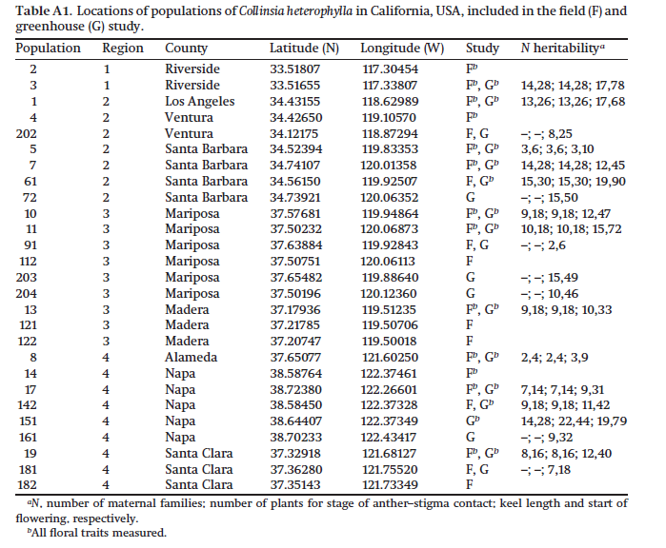

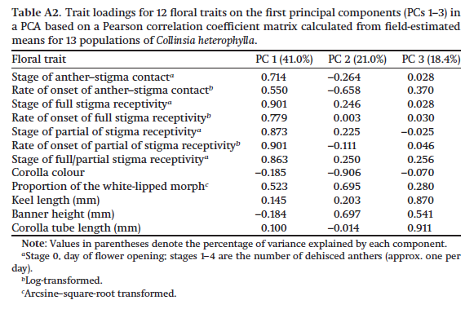

**Data published in**: Strandh, M., Jönsson, J., Madidian, J.A., Hansson, B., **Lankinen, Å.**, 2017. Natural selection acts on floral traits associated with selfing rate among populations of mixed-mating *Collinsia heterophylla* (Plantaginaceae). International Journal of Plant Sciences 178: 594-606. doi: 10.1086/693464

**Plant material and study populations**

A field study of 21 Californian populations in four geographic sampling regions in late April and early May of 2008 (Lankinen et al. 2017) provided plant material for microsatellite

estimates and measures of environmental site characteristics. We collected floral trait estimates in the greenhouse in 2011 in plants grown directly from the field-collected seeds,

representing genetically determined floral variation. To increase sample sizes for regression analysis of mating systems on floral traits, we included additional greenhouse measures for four of the populations from Madjidian and Lankinen (2009). The sample range of the populations represents about two thirds of the north-south range of the species. We aimed to

sample populations that covered most of the environmental variation influencing this species, but for practical reasons we selected four geographic regions of the total study area (following Lankinen et al. 2017). Region 1 is represented by the Santa Ana Mountains south of Los Angeles (Riverside County), and region 2 is represented by the Transverse Ranges and the Coast Ranges north of Los Angeles (Los Angeles, Ventura, and Santa Barbara Counties). Farther north, region 3 is represented by the SierraNevadaMountains (Mariposa andMadera

Counties), and region 4 is represented by the Coast Ranges around the Bay Area (Santa Clara, Alameda, and Napa Counties).

**Microsatellite Screening**

We used dried leaves collected from an average of 20 individuals per population (mean 5 SD: 20.2 5 7.9; Npop p 21) for DNA extraction using either the DNeasy Plant Mini Kit

(Qiagen) or the GeneJET Plant Genomic DNA Purification Kit (Fermentas; Thermo Fisher Scientific), in accordance with the manufacturer’s instructions. We amplified four polymorphic microsatellite loci (A11, A106, A116, and C1) developed for C. sparsiflora (J. W. Wright and M. L. Stanton, Forest Service Pacific Southwest Research Station, USDA, unpublished data) in one multiplex polymerase chain reaction (PCR; containing four primer pairs) per individual, as described in Hersh et al. (2015). We analyzed the PCR products by GeneScan fragment analysis, adding GeneScan 500 ROX size standard (Applied

Biosystems) to the samples on an ABI3730XL DNA analyzer (Applied Biosystems) at the Uppsala Genome Center, Sweden. We used the resulting chromatograms for genotyping

by size determination with the Microsatellite Plugin in Geneious software (ver. 6.1.4; Biomatters).

**Population Selfing Rates**

We calculated selfing rate (S) as S p 2FIS/(1 1 FIS) (Jarne and David 2008) based on estimates of the overall population inbreeding coefficient (FIS) generated from the microsatellite genotype data by means of the Excel plugin GENALEX (ver. 6.5; Peakall and Smouse 2006, 2012) (= selfing rate in excel file). We also estimated selfing rate with RMES software because this method is insensitive to null alleles, partial dominance, and scoring errors, which otherwise may lead to overestimation of selfing rates (David et al. 2007). However, the RMES method is sensitive to certain types of gametic disequilibria (David et al. 2007). We were able to get reliable estimates for only four populations with the RMES method. We used these data to compare selfing rates estimated with both methods. We also evaluated the robustness of FIS estimates of selfing rate based on an increasing number of included genotypes (N p 2–35) for four populations. The selfing rate estimates stabilized (SNmax 5 0.05) at N p 7–14, showing that even with few genotypes per population our estimates of FIS are robust.

**References**

David P, B Pujol, F Viard, V Castella, J Goudet 2007 Reliable selfing rate estimates from imperfect population genetic data. Mol Ecol 16:2474–2487.

Hersh E, JA Madjidian, S Andersson, M Strandh, WS Armbruster, Å Lankinen 2015 Sexual antagonism in the pistil varies among populations of a hermaphroditic mixed-mating plant. J Evol Biol 28:1321–1334.

Jarne P, P David 2008 Quantifying inbreeding in natural populations of hermaphroditic organisms. Heredity 100:431–439.

Lankinen Å, JA Madjidian, S Andersson 2017 Geographic variation in floral traits is associated with environmental and genetic differences among populations of the mixed mating species *Collinsia heterophylla* (Plantaginaceae). Botany 95:121–138.

Madjidian JA, Å Lankinen 2009 Sexual conflict and sexually antagonistic coevolution in an annual plant. PLoS One 4:e5477.

Peakall R, PE Smouse 2006 GenAlEx 6: genetic analysis in Excel. Population genetic software for teaching and research. Mol Ecol 6:288–295.

——— 2012 GenAlEx 6.5: genetic analysis in Excel. Population genetic software for teaching and research—an update. Bioinformatics 28:2537–2539.